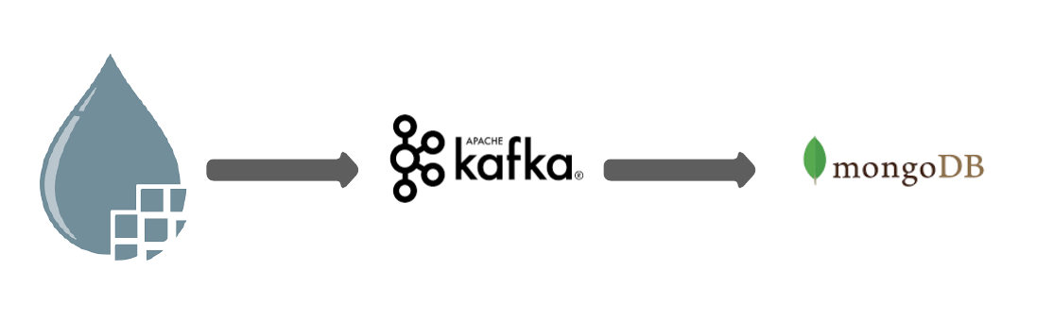

Ingestion of Streaming Aviation Data

*Step-1:* Start the Apache NiFi using following commands-

* ./nifi-env.sh start
* ./nifi.sh start

*Step-2:* Go to the localhost:8080 to access the NiFi user interface.

*Step-3:* Drag down the following processors one by one:

1. InvokeHTTP
2. SplitJSON
3. EvaluateJSONPath
4. AttributesToJSON
5. PublishKafka
6. ConsumeKafka (Should be of same version as PublishKafka)
7. PutMongoDB

*Step-4:* Connect them in this order and specify the relationship among the processors as shown in the template.

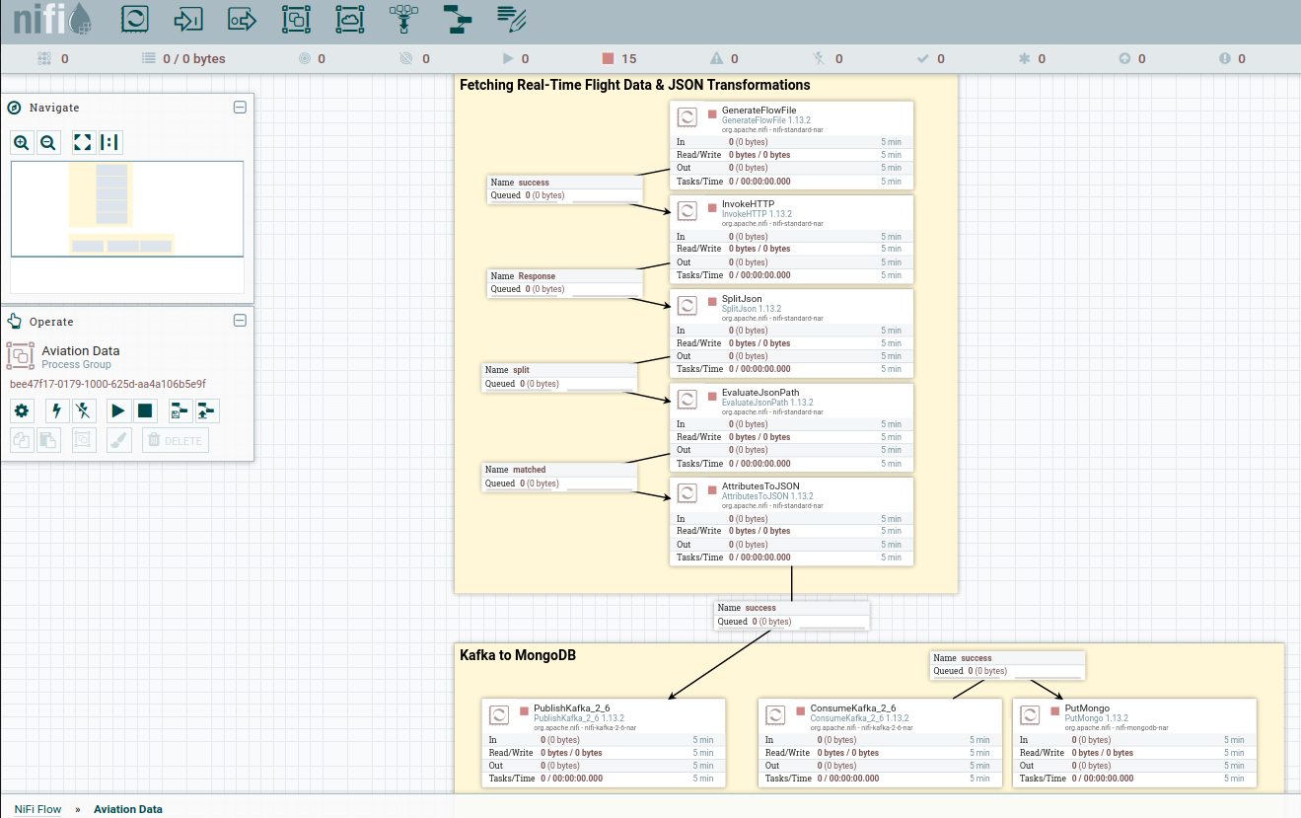

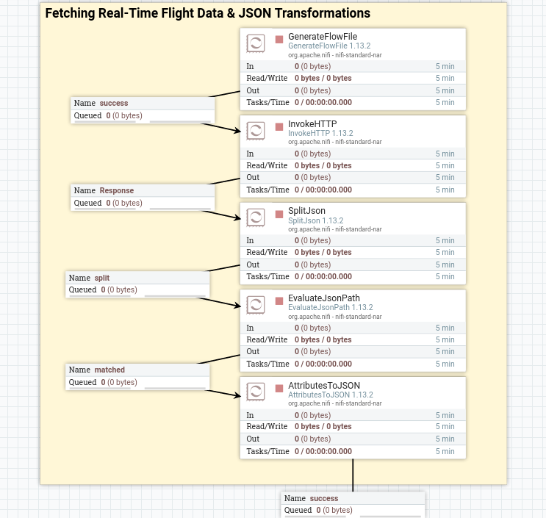

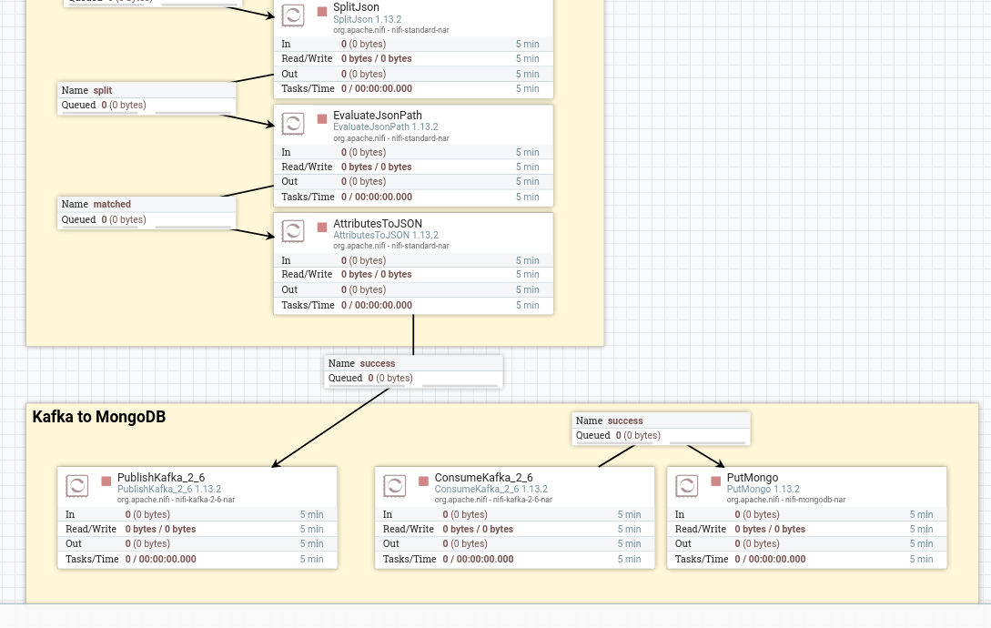

Step-5: Start the processor to start the real time stream of data.